Rifat Khan

Sadat Tashin, Daniel Zalivansky

Gravitational Acceleration Lab

**Introduction**

In this lab exercise, our goal is to observe the gravitational force of an object as the object free falls to the earth’s surface. We want to experimentally measure the earth’s acceleration of a free falling object and then compare it to the accepted value of 9.81 m/s2. We hope to learn how the force of gravity affects how objects fall in space.

**Journal**

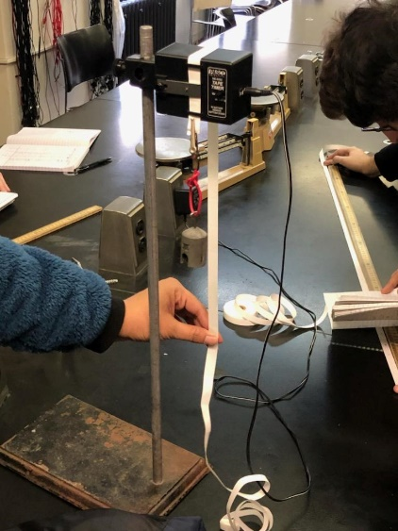While performing this experiment, one thing that we had trouble with was recording the data that was present on the tape due to the fact that the dots on the tape were very faint and hard to read.

This is a picture of the setup taken by my group member

**Data**

Figure 1: Distance and velocity of the object over time.

|  |  |  |  |
| --- | --- | --- | --- |
| Data Point | x (cm) | t (s) | V (m/s2) |
| 0 | 0 | 0 | 0 |
| 1 | 1.4 | 1/40 | 56 |
| 2 | 3.1 | 2/40 | 68 |
| 3 | 5.2 | 3/40 | 84 |
| 4 | 8 | 4/40 | 112 |
| 5 | 11.4 | 5/40 | 136 |
| 6 | 15.2 | 6/40 | 152 |
| 7 | 19.7 | 7/40 | 180 |
| 8 | 24.8 | 8/40 | 204 |
| 9 | 30.3 | 9/40 | 220 |
| 10 | 36.5 | 10/40 | 248 |
| 11 | 43.2 | 11/40 | 268 |
| 12 | 50.4 | 12/40 | 288 |
| 13 | 58.2 | 13/40 | 312 |
| 14 | 66.6 | 14/40 | 336 |
| 15 | 75.3 | 15/40 | 348 |
| 16 | 85 | 16/40 | 388 |
| 17 | 95.1 | 17/40 | 404 |

According to the linear regression analysis, the calculated acceleration value was 9.05 m/s2

**Calculations**

Sources of Error: One source or error that could’ve affected the results of our experiment was the accuracy of the tape timer. The tape timer did not record the dots at perfect accuracy which would have affected the timing and the distances of the balls. Additionally, another source of error was the fact that in order to calculate the acceleration, we used the slope of a best fit line even though the best fit line isn’t fully representative of the data.

Percent Error: (9.81 – 9.05)/9.05 * 100 = 8.3% error

**Conclusion**

After performing this experiment, the experimental acceleration that we were able to calculate was 9.05 m/s2, which differs from the generally accepted value of 9.81 m/s2. Through performing this experiment we were able to understand the physics behind a freefalling object and we were able to learn how the velocity of an object changes as it falls through the air. I was able to understand how the velocity increases as time passes and through the entire time the object is falling, the object was accelerating at a constant rate which we were able to calculate. After graphing the data, I was also able to realize that the slope of a velocity vs time graph is equivalent to the acceleration.